

**Molloy Nursing Student Association**

**The Pulse**

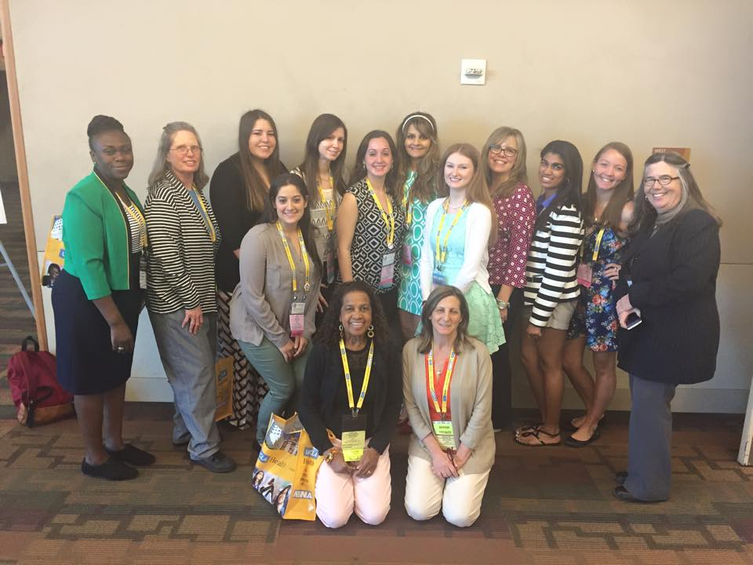

Volume 1 Issue 2

**Meet the Executive Board for the 2015-2016 School Year!**

**Co-Presidents**

Samantha Bishop

Jaclyn Malone

**Co-Vice Presidents**

Katelyn Finnegan

Karine Brisson

**Co-Secretaries**

Philip DeSena

Julia White

**Co-Treasurers**

Rachel White

Emily Rosen

**Co-Communications Directors**

Stephanie Jorgensen

Teresa McDavid

**Club Advisers**

Dr. Geraldine Moore

Dr. Lorraine Emeghebo

Margaret Mullarkey

**Happy Holidays from Molloy Nursing Student Association!**

MNSA wants to wish all of the nursing student happy holidays. We hope you all do amazing on your finals!!!

**Thank you to all that came and walked with MNSA!**

We appreciate everyone who came out to the Breast Cancer Walk as well as the Out of the Darkness Walk. Both Breast Cancer and Suicide have affected many of us and it was great to see such amazing support!

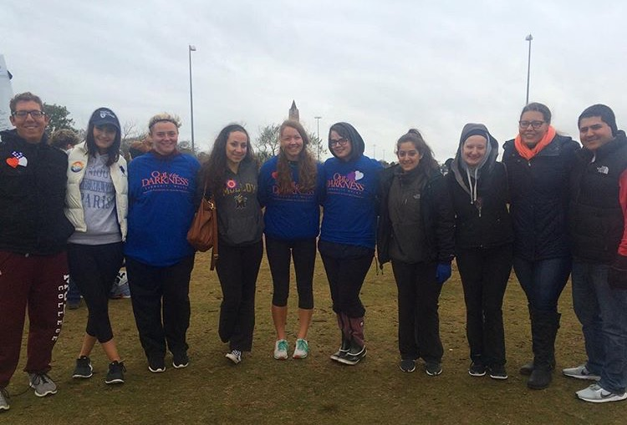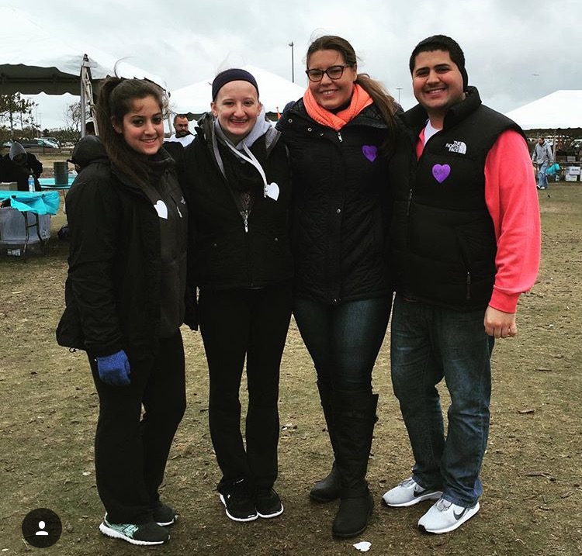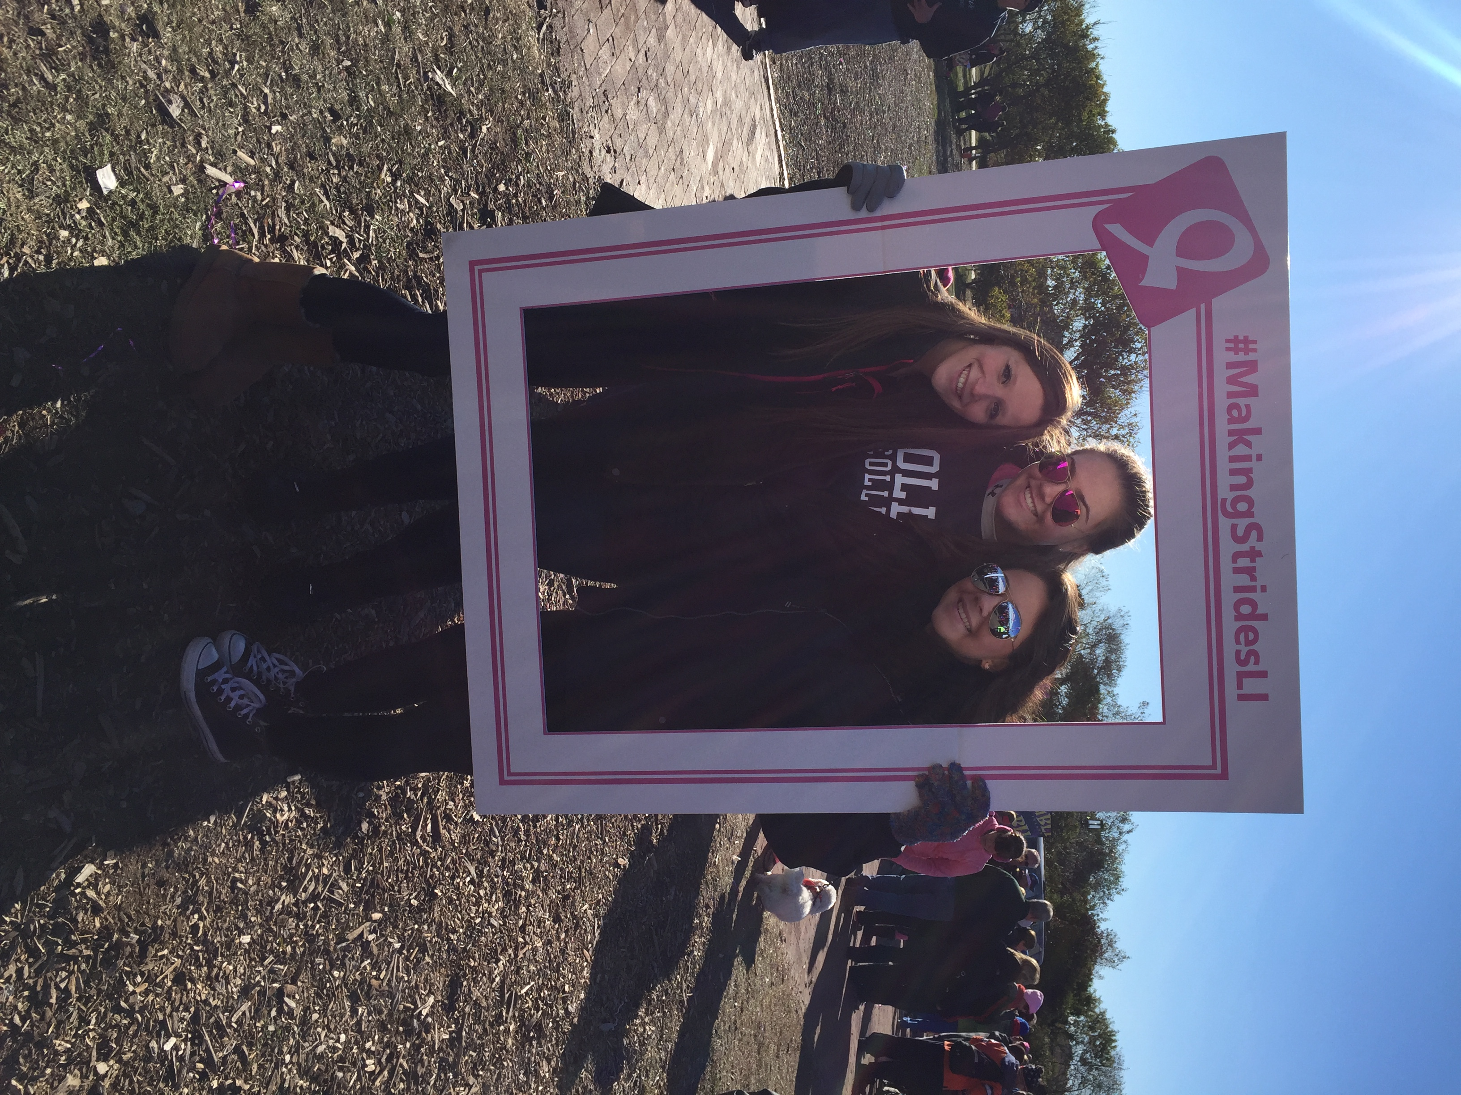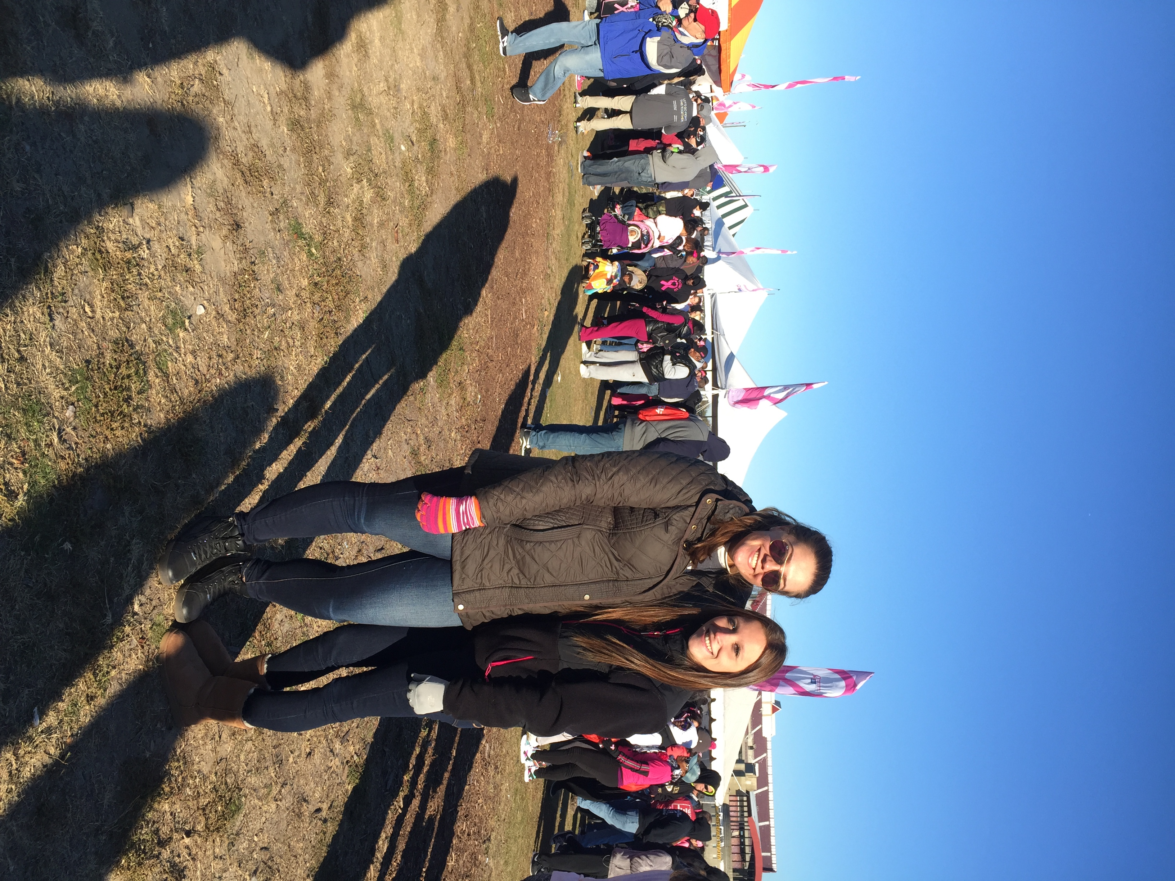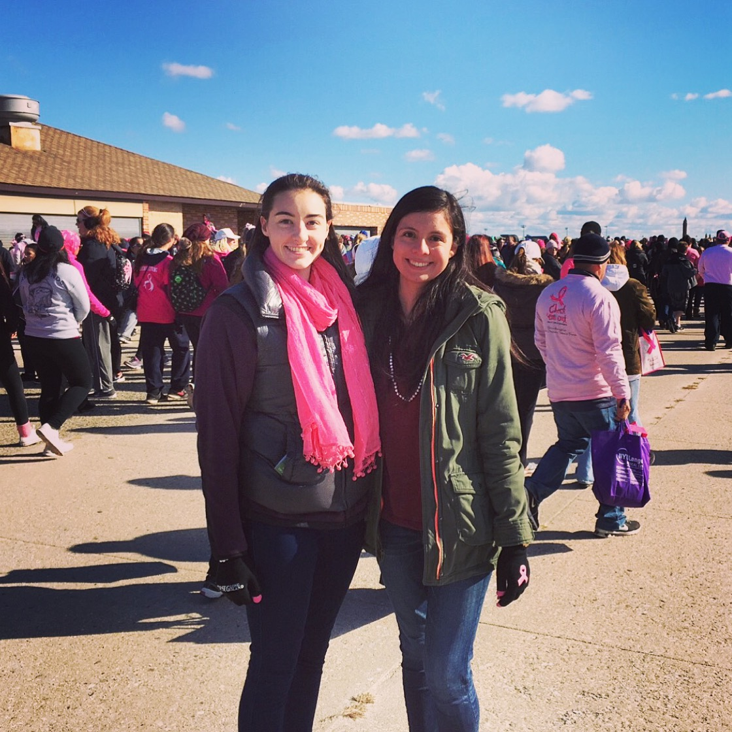

**There Is Something Special about a**

**Molloy Nurse**

**Thank you to those who joined NSNA!**

The National Student Nurses’ Association is a pre-professional association for nursing students started in 1952. It is a great opportunity for nursing students. NSNA has a huge network which gives you the opportunity to work hand in hand with students and mentors from across the country. Benefits for joining include:

* Numerous conventions which have seminars on: networking, resume building, NCLEX review
* The opportunity to work with nursing students from all over the country
* Up to date information about current events that are happening in the nursing community through Imprint Magazine
* Scholarship opportunities
* Educational resources
* Leadership opportunities
* Discounts on scrubs, office supplies and professional portfolio review services

**Here is a link for more information regarding NSNA:** [**http://www.nsna.org/**](http://www.nsna.org/)

**More info about NSNA by Goggling “NSNA catching the wave video”**

**Scholarships: Due January 29th, 2016 -** [**http://www.forevernursing.org/**](http://www.forevernursing.org/)

**Joining NSNA gives you the opportunity to work with NSANYS.**

NSANYS is the Nursing Students’ Association of New York. NSANYS is the New York Division of NSNA. Founded in 1951, the purpose of Nursing Students’ Association of New York State (NSANYS) is to aid in the transition from undergraduate student nurses to the professional world. Our goal is to help mold the future of nursing

by first developing accountable, responsible and motivated leaders.

**SAVE THE DATE:**

**NSANYS 64th Annual Convention  
Reaching the Stars in Nursing on Broadway  
Saturday, February 20, 2016  
7:00 am - 6:00 pm  
New York's Hotel Pennsylvania  
401 7th Ave, New York, NY 10019**

And here is a link for more information regarding NSANYS:

[**http://www.nsanys.org/**](http://www.nsanys.org/)

**Let’s Be an “All in School”**

**Education Club’s Reason for a Season**

**Sunday December 6th, 2015**

**1:00pm-3:00pm**

**Anselma Room**

**The toys we raised during The Party with a Purpose will be donated to the families on this day.**

# MNSA Party with a Purpose

**December 4th, 2015**

**5:00 p.m. to 7:00 p.m.**

**Larini Room on the 2nd floor of Public Square**

**MNSA is teaming up with the Education club to help collect toys to donate to children!!!**

**Donations will benefit the Child Life Program at Cohen’s Children’s Medical Center & the Ronald McDonald House**

**Please bring one or some of the following:**

**Teething rings, Cause & Effect Toys, Play Dough, Puzzles, Matchbox Cars, Decks of Uno, Barbie Dolls, Baby Dolls, Super Hero Toys, Board Games, Small Lego Sets, Craft Sets, Books**

**If you wish to attend, please email** [**mnsa@lions.molloy.edu**](mailto:mnsa@lions.molloy.edu) **with the toy you are bringing.**

**PLEASE MAKE SURE ALL ITEMS ARE NEW and IN ORIGINAL PACKAGING**

**For any questions contact mnsa@lions.molloy.edu**



**Molloy Nursing Student Association (MNSA)**

***What is it?***

Molloy Nursing Student Association is a student-run organization whose mission is for students to pursue academic excellence while building leadership roles as a result of being active on campus and in the community.

MNSA is a chapter of National Student Nurses Association (NSNA) and Nursing Students Association of New York State (NSANYS) pre-professional organizations.

MNSA members attend state and national conventions, hold speaker events, participate in different community service activities, fundraise and raise awareness for different diseases/disasters, host our annual *Party with a Purpose* event on campus, and collaborate with other student organizations at Molloy.

***What are its goals?***

* To unite nursing students from Molloy College.
* To inspire enthusiasm in Molloy College Nursing Students about the profession of nursing.
* To establish a sense of pride in being a Molloy College Nursing Student.
* To provide community service for the purposes of helping others as well as ourselves to grow.
* To welcome and to provide mentoring, guidance and a sense of belonging for new nursing students.
* To help facilitate regular communication between Molloy College Nursing Students and Molloy College Nursing Faculty.

***How do I become a member?***

Any student who pays a student activities fee for each semester can be a member of the MNSA. Active membership is determined by attendance at three (3) meetings per semester. Meetings will be held once a month at specific times.

***How can I find out more about it?***

**Website: molloynsa.weebly.com**

You can e-mail us at [mnsa@lions.molloy.edu](mailto:mnsa@lions.molloy.edu) or find us on Facebook at <http://www.facebook.com/pages/Molloy-Nursing-Student-Association-MNSA/128017647259739>.

Does this sound like something you would like to be a part of?

Come and join us!



Drug Calc Questions:

1. The physician orders an IV infusion of D5W 1000 ml to infuse over the next eight hours. The IV tubing that you are using delivers 15gtt/min. What is the correct rate of flow?
2. 1000cc solution of D5NS with 20,000 units of Heparin is infusing at 20ml per hour. The IV set delivers 60 gtts per cc. How many units of Heparin is the patient receiving each hour?
3. The order reads: "Over the next 4 hours, infuse 500 ml of 5% Dextrose in Normal Saline. Add 20 MEq of KCl to solution." You know that the IV tubing set is calibrated to deliver 10gtt/ml. In drops per minute, what is the rate of flow?
4. Azulfidine 1.5 g has been ordered every twelve hours. The available tablets are 500 mg each. How many tablets will you give?

It has been said that nurses truly touch the lives of their patients. But on the flip side of that story, patients truly touch the lives of nurses. As a senior nursing student, I have had the opportunity of many clinical experiences. Of these, I have met so many different people: nurses, patients, doctors, physical therapists you name it. However, there was one patient who made such an impact on my life that I don’t think I will ever forget. I was in my fundamentals class. Students always say that this is the most boring clinical because “all they do is bed baths.” As I look back at it now I felt as if it was the most nerve racking of all the clinical experiences. This is largely because I did not know how to talk to a patient. I was scared, of what they might think of me, if I was annoying to them, if they really wanted me there, and if I was saying the right thing. It was not until I met this patient that all of those feelings seemed not to matter anymore. I was on the floor talking with my friends when I heard someone crying very loudly. I walked up and down the halls trying to track where the crying was coming from. As I approached the room, a doctor came out and said please go in and comfort that patient. I did not know anything about this patient. I didn’t know what the doctor told her, her diagnosis, her age, and not even her name. Nonetheless, I entered the room and there was a sign above her bed that said legally blind. I moved closer to the patient as she was crying and sat next to her. I didn’t know what to say to her, so without saying a word I just grabbed her hand and held it. She placed her other hand over mine and squeezed it tight. She told me that the doctor told her that she had cancer and that it had metastasized. I knew that news like this would be hard for anyone to hear, so I simply whispered to her “I’m here for you,” She sat up on the bed and hugged me. This is the most beautiful thing that has ever happened to me. This woman did not even know what I looked like, but in that moment we had a true human connection. I wasn’t worried about what the patient thought of me or if I was saying the right thing. I was just there for the patient and that is what made the difference. This is the most valuable learning experience I have had in clinical thus far. It seems so simple, but it something that many people need. That feeling of being connected and cared about is in the deepest part of our humanity. I never underestimate the impact that I can make on a

patient or the impact that they make on me.

By: Stephanie McAuley



**The Pulse November/December 2015 Issue**

**A Human Connection**

**Final Exam Tips**

* Create a master to-do list and a schedule for the remaining days in the semester. Break cumulative exams into smaller study units, which will prevent you from feeling overwhelmed and help you monitor your progress daily.
* Just get started. Don’t wait until you feel like studying.
* Identify the format of the exam. Vary your study technique according to the type of exam.
* Predict possible questions. Review old tests, study guides or the course objectives.
* Answer questions you didn’t know the first time. If the exam is cumulative and you struggled to master any material, return to it.
* Check the front of your textbook to see if the publisher provides any online study aids.
* Set specific measurable goals for each study session to keep yourself on track.
* Create mnemonic devices, such as acrostics, rhymes or acronyms, to help you remember information.
* Take short breaks. Your brain can process a limited amount of information and benefits from some rest.
* Explain it aloud. Go into an empty classroom and pretend to teach the material to someone. Using your own words helps you assess your comprehension, which ultimately aids your memory.

**MNSA Contact Information**

**Email:** [**mnsa@lions.molloy.edu**](mailto:mnsa@lions.molloy.edu)

**Facebook: Molloy Nursing Student Association (MNSA)**

**Instagram: m.n.s.a**

**Twitter: molloynsa**

**Website:** [**molloynsa.weebly.com**](mailto:molloynsa@weebly.com)

**Would you like to write an article for The Pulse? Email Stephanie Jorgensen and Teresa McDavid for more information!**

**Stephanie Jorgensen:** [**sjorgensen@lions.molloy.edu**](mailto:sjorgensen@lions.molloy.edu)

**Teresa McDavid:** [**tmcdavid@lions.molloy.edu**](mailto:tmcdavid@lions.molloy.edu)

**Drug Calculation Answers**

**1. 31 gtts/min 2. 400 units/hr 3. 21 gtts/min 4. 3 tablets**

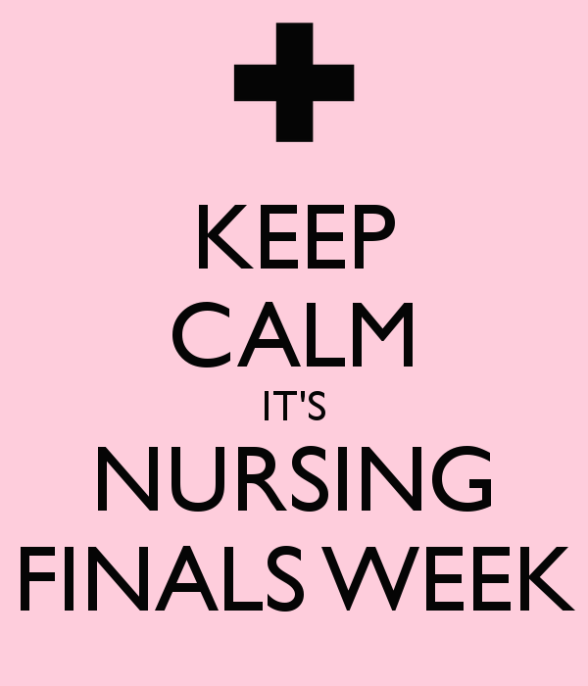

**MNSA’s Upcoming Events for the 2015-2016 School Year**

|  |  |  |
| --- | --- | --- |
| November 12th, 2015  December 4th, 2015  February 2nd, 2016  March 1st, 2016  April 5th, 2016 | Veteran’s Day Meeting  Party with a Purpose  Minorities in Nursing  New Grad Panel Meeting  Meeting with Nurse Recruiters | Larini Room  Larini Room  Madison Theater  Madison Theater  Madison Theater |