**Molloy Nursing Student Association**

**The Pulse**

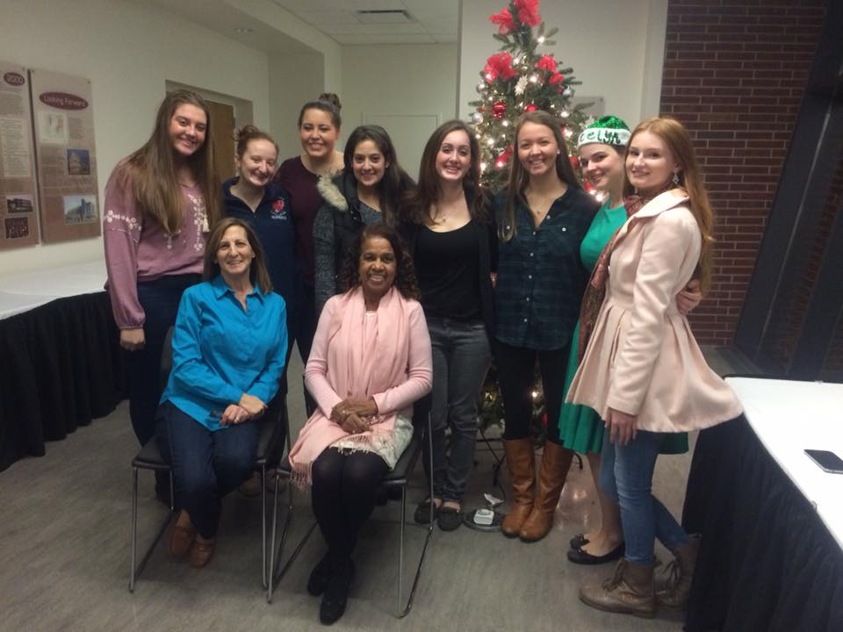

**Meet the Executive Board for the 2015-2016 School Year!**

**Co-Presidents**

Samantha Bishop

Jaclyn Malone

**Co-Vice Presidents**

Katelyn Finnegan

**Co-Secretaries**

Philip DeSena

Julia White

**Co-Treasurers**

Rachel White

Emily Rosen

**Co-Communications Directors**

Stephanie Jorgensen

Teresa McDavid

**Club Advisers**

Dr. Geraldine Moore

Dr. Lorraine Emeghebo

Margaret Mullarkey

**MNSA at the Party with a Purpose**

Happy New Year!

MNSA hope everyone had a great break and we welcome all of you back! We wanted to thank everyone who came out to our Party with a Purpose! You made a big difference.

MNSA wishes you a great semester and an amazing new year! Let’s make 2016 count!



***Who is MNSA?***

Molloy Nursing Student Association is a student-run organization whose mission is for students to pursue academic excellence while building leadership roles as a result of being active on campus and in the community.

MNSA is a chapter of National Student Nurses Association (NSNA) and Nursing Students Association of New York State (NSANYS) pre-professional organizations.

MNSA members attend state and national conventions, hold speaker events, participate in different community service activities, fundraise and raise awareness for different diseases/disasters, host our annual *Party with a Purpose* event on campus, and collaborate with other student organizations at Molloy.

***How do I become a member?***

Any student who pays a student activities fee for each semester can be a member of the MNSA. Active membership is determined by attendance at three (3) meetings per semester. Meetings will be held once a month at specific times.



“People will forget what you said, people will forget what you did, but people will never forget how you made them feel.

“ –Maya Angelou



**Page 1 Molloy Nursing Student Association - The Pulse**



**SAVE THE DATE:**

**NSANYS 64th Annual Convention  
Reaching the Stars in Nursing on Broadway  
Saturday, February 20, 2016  
7:00 am - 6:00 pm  
New York's Hotel Pennsylvania  
401 7th Ave, New York, NY 10019**

**Molloy Nursing Student Association - The Pulse**



Who is NSANYS?

NSANYS is the Nursing Students’ Association of New York. NSANYS is the New York Division of NSNA. Founded in 1951, the purpose of Nursing Students’ Association of New York State (NSANYS) is to aid in the transition from undergraduate student nurses to the professional world. Our goal is to help mold the future of nursing by first developing accountable, responsible and motivated leaders.

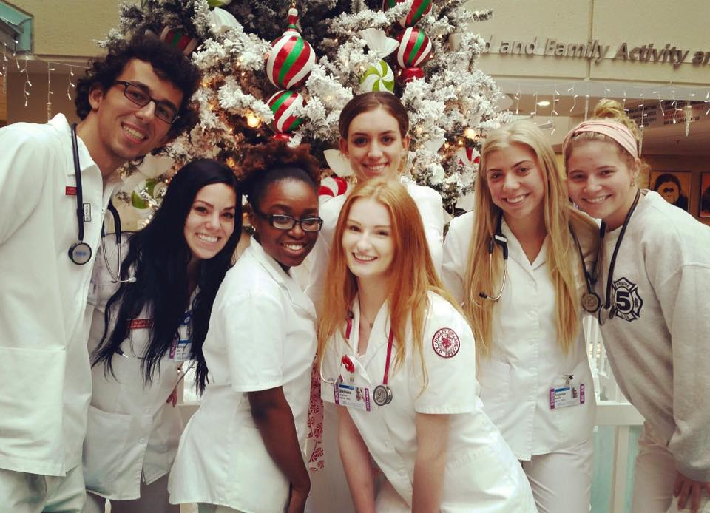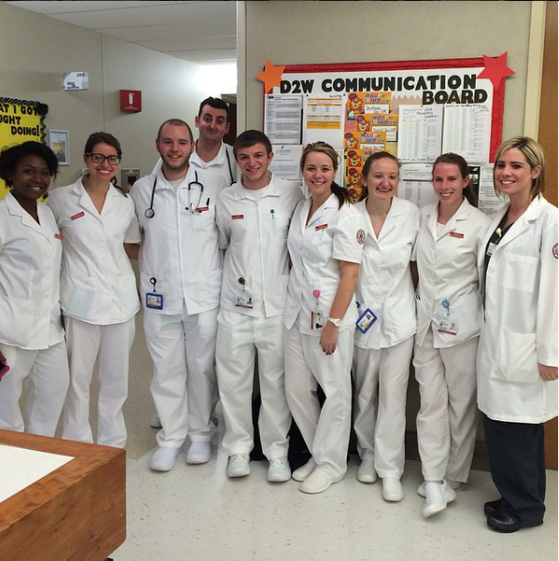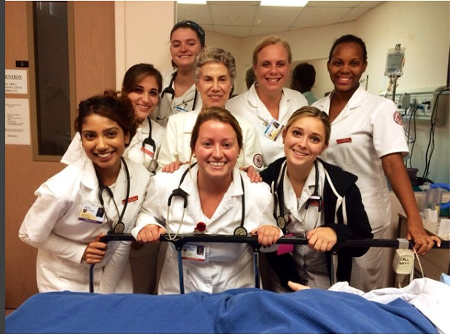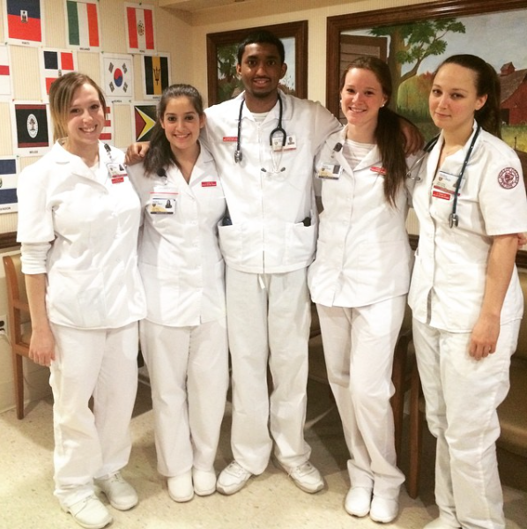

**Clinical Pictures!**



**Page 2**

**MNSA’s Upcoming Events for the 2015-2016 School Year**

**Date Topic Location & Time**

|  |  |  |
| --- | --- | --- |
| February 2nd, 2016  March 1st, 2016  April 5th, 2016 | Medication Safety  New Grad Panel Meeting  Meeting with Nurse Recruiters | Madison Theater (3:30 – 4:30pm)  Madison Theater (3:30 – 4:30pm)  Madison Theater (3:30 – 4:30pm) |
|  |  |  |

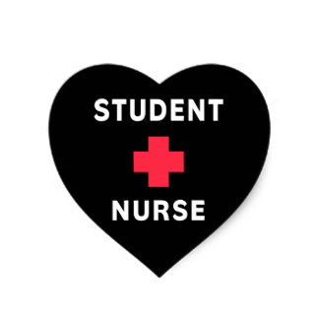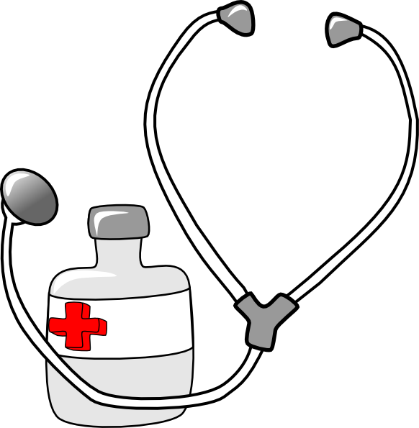

**Page 3 Molloy Nursing Student Association - The Pulse**

Drug Calc Questions

1. 100 mls of IV Fluids to be given over a half hour via a giving set which delivers 10 drops/ml. Calculate the number of drops per minute.
2. One liter of Normal Saline is charted over 9 hours. The drop factor is 15drops/ml. Calculate the number of drops per minute.
3. A client is ordered 30 milligrams of Lasix intravenously. 10 milligrams in 1 milliliter of liquid for IV Injection is available. How many milliliters will you administer?
4. A client is ordered 37.5 milligrams of Nortriptyline 25 milligram tablets are available. How many tablets will you give?

My First Clinical Experience:

By: McCaila Heady

I was always told horror stories about the clinical experience, so naturally my anxiety was through the roof for my first day. I left the dorms an hour early and only had to drive 15 minutes but I figured I'd get a good parking spot. I had heard we could park at the train station so that was exactly where I went. I got there at 6:15, excited that I had a good spot and time to spare. After taking a few "first day of clinical" selfies, I finally read the sign that said "2 hour parking". I then tried to start my car but my '95 jeep, (who I called old rusty) didn't want to start. I panicked and had a security officer jump my car, grateful I pulled away and started driving to the near by neighborhood. Not even a mile away and old rusty died right in the middle of the street. Not knowing what to do, I called the hospital security again. I had people coming out of their homes to help along side the security guards and finally got my poor jeep to the side of the road. In between the panic attacks, I called my clinical instructor to tell her what had happened and why I would be late. I braced myself for a verbal beating however, she was very understanding and told me to take my time. I finally arrived to pre-conference at 7:30 am, she smiled and asked if I needed a cup of tea or coffee to relax. I was so relieved and grateful that she didn't yell at me and we still keep in contact to this day. Although, my first clinical day started as a nightmare, it ended as a great learning experience.

**Molloy Nursing Student Association - The Pulse**

**Page 4**

Take pride in how far you have come, and have faith in how far you can go!

Will it be easy? Nope. Will it be worth it? Absolutely.

You have a brain in your head. You have feet in your shoes. You can steer yourself in any direction you choose.

Strive for progress and not perfection.

7 Tips to Survive Stress and Get Through Nursing School

Motivational Quotes

Drug Calc Answers

1. 33 gtts/min.
2. 28 gtts/min
3. 3 mL
4. 1.5 tablets
5. Maintain a healthy lifestyle
6. Set realistic, measurable goals
7. Get a good nights sleep
8. Find a study buddy
9. Take time to do something for you
10. If you need a tutor, sign up online with the AcE center
11. Try not to procrastinate!



With the Winter Season Coming Make Sure You Are Signed Up with Molloy’s Emergency Notification System!



With the Rave Emergency Notification System you will receive messages and instruction regarding campus-wide emergencies and school closings. If you haven't already, we kindly request that you sign up to be notified electronically should an emergency arise on campus. You will only be notified via a text message should a major emergency arise. The system will not be used for minor situations such as weather advisories, campus event notifications or cancellations of any kind.

**To register for the emergency notification system**

Go to Molloy's registration page at <https://www.getrave.com/login/molloy>

* Click on the blue "Register Now" button on the left side
* Use your Molloy College email and establish your own password
* Fill out your preferences to be notified: Name, mobile number, preferred email and read the terms and conditions
* Confirm your carrier and mobile phone number
* Please remember to update your information with any changes.

If you need assistance please, contact the Department of Public Safety at 516.323.3500 from Monday to Friday from 8 a.m. to 4 p.m .



**MNSA Contact Information**

**Email:** [**mnsa@lions.molloy.edu**](mailto:mnsa@lions.molloy.edu)

**Facebook: Molloy Nursing Student Association (MNSA)**

**Instagram: m.n.s.a**

**Twitter: molloynsa**

**Website:** [**molloynsa.weebly.com**](mailto:molloynsa@weebly.com)

**Would you like to write an article for The Pulse? Email Stephanie Jorgensen and Teresa McDavid for more information!**

**Stephanie Jorgensen:** [**sjorgensen@lions.molloy.edu**](mailto:sjorgensen@lions.molloy.edu)

**Teresa McDavid:** [**tmcdavid@lions.molloy.edu**](mailto:tmcdavid@lions.molloy.edu)

