MNSA meeting: New Grad Panel & Guide Dog foundation
Present: Julia, Rachel, Teresa, Steph, Emily, Sam, Jackie, Dr. Moore, Professor Mullarkey
Not present: Phil, Kaitlyn (both at clinical, excused), Doctor Emeghebo
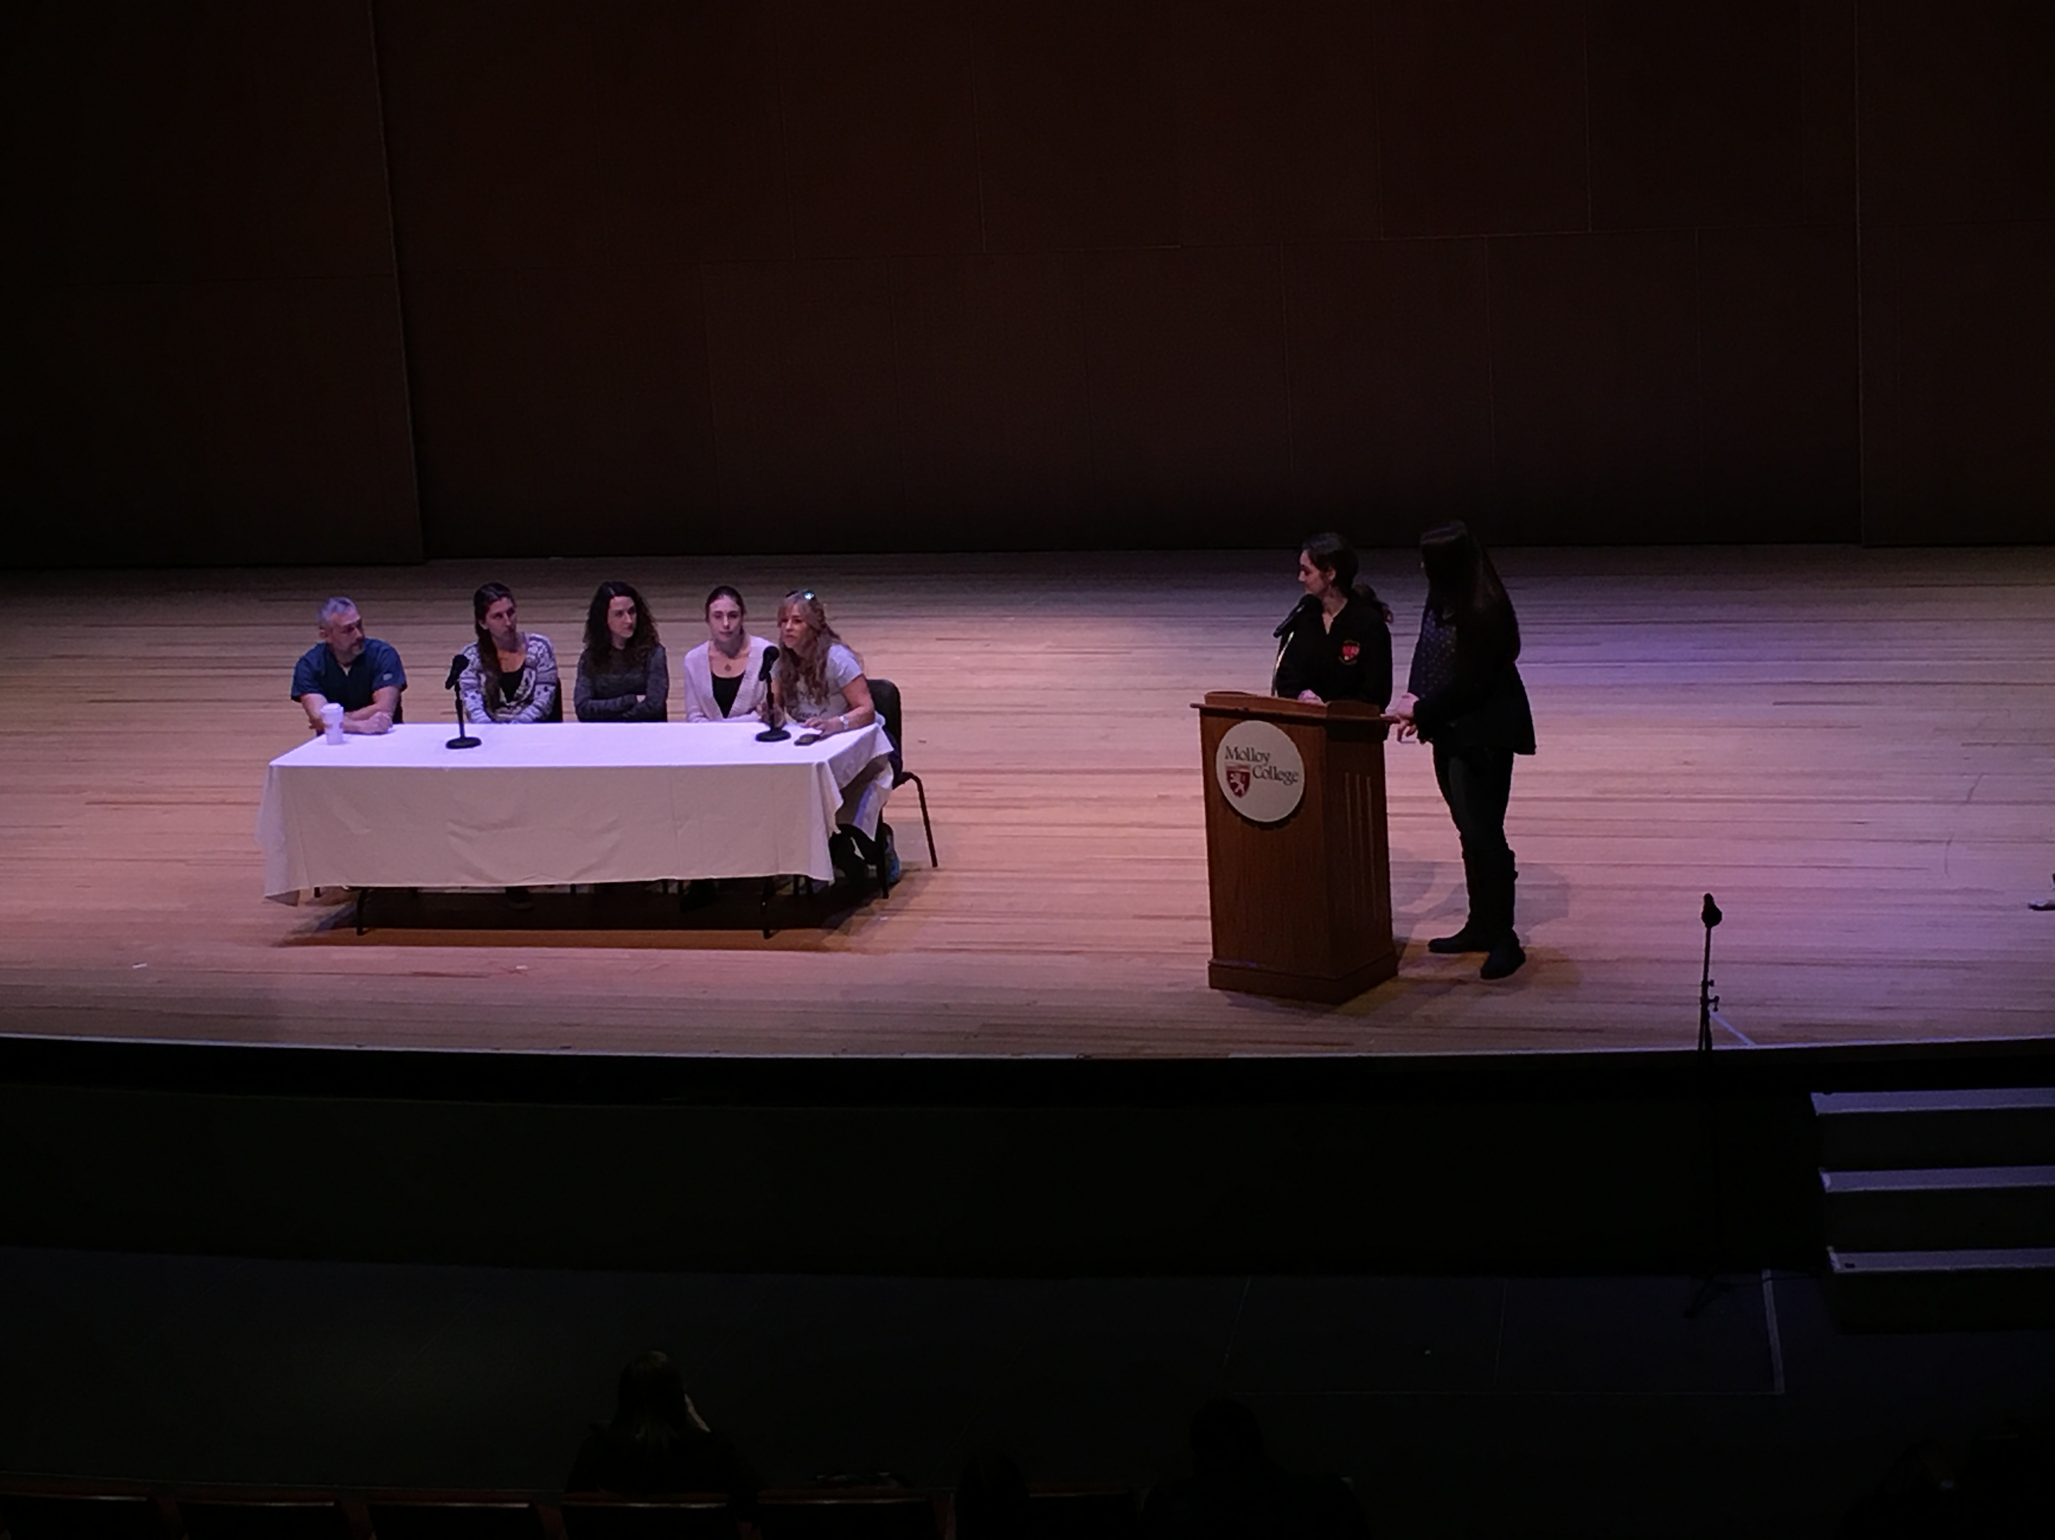
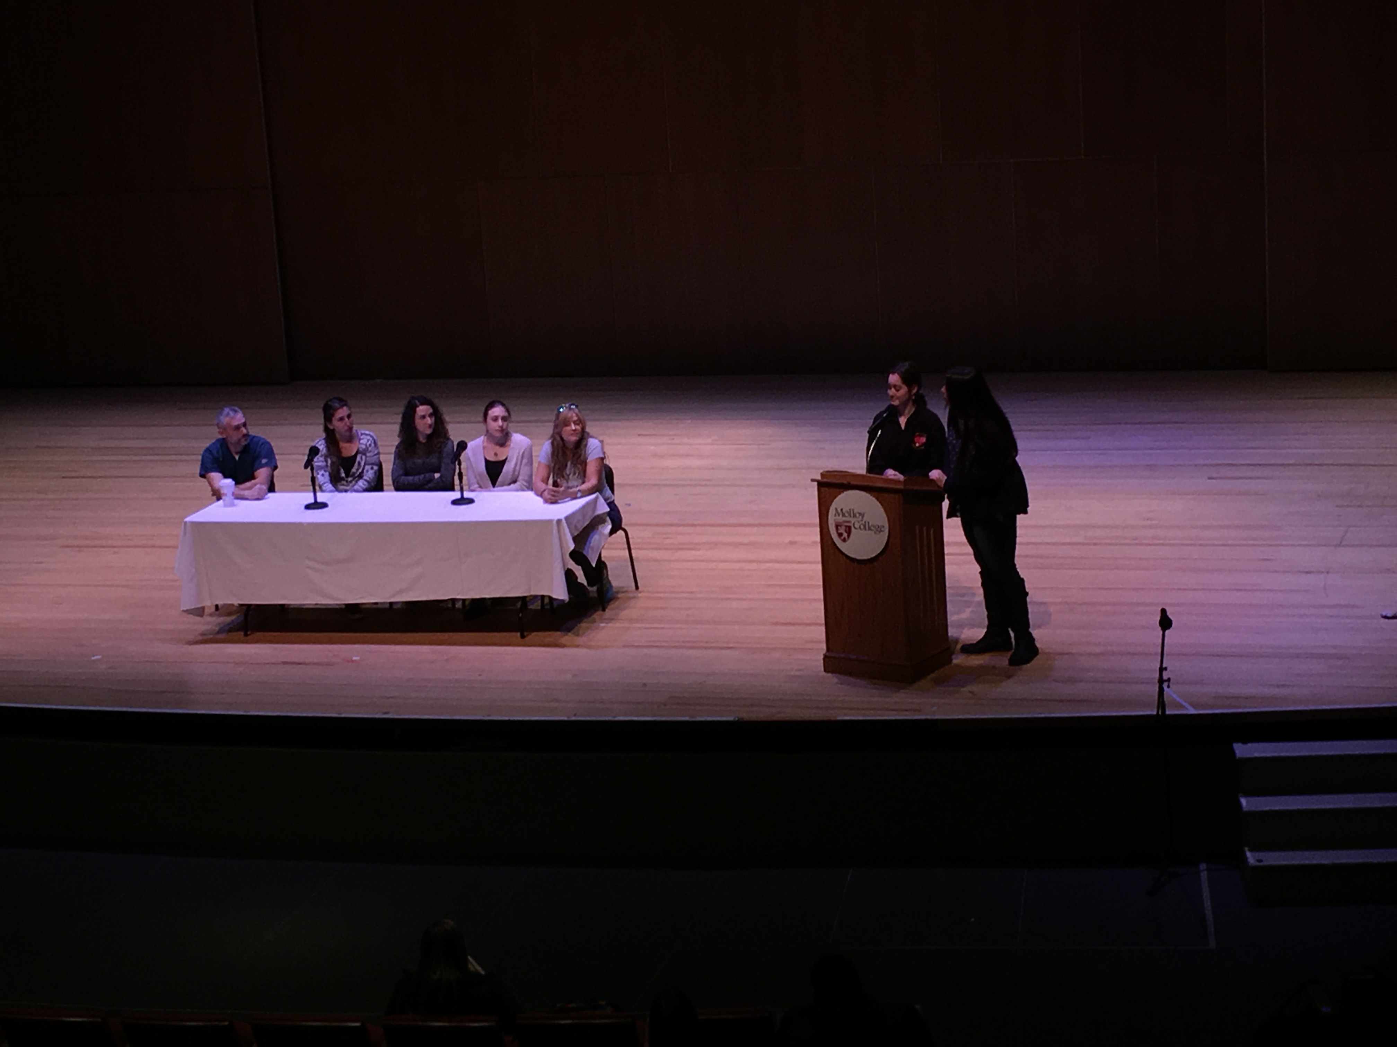
Number Present: 34
Speakers:
- Bob- South Nassau (ED resident)
- Hope- New York Presbyterian (Med Surg/ Telemetry unit)
- Katie-Sloan Kettering Memorial Hospital (Bone Marrow transplant floor)
- Toni-New York Presbyterian (Labor and Delivery)
- Christina-Saint Francis (Cardio Step down unit)
What tips do you have when preparing for the NCLEX?
- Take a prep course (Kaplan, Hearst), do tons and tons of questions, do not get discouraged if you don't pass the first time
- Don’t be so focused with content, do it for the ones you are not confident about.
- Stay positive
- If money is tight use your resources.
- Understand why you're getting the practice questions correct / incorrect
- Lippincott's Q&A Review for NCLEX-RN is the most realistic book.
What was the biggest challenges about getting a job?
- Make contacts way before you're ready to start searching.
- Be proactive, write thank you notes.
- Pick up part time Nursing Assistant jobs/nurse Externships
- Have resume ready
- Come with questions to your interview
- Treat your preceptorship like it is your job interview.
- Build up your resume.
- Work as hard as you can
- Molloy has great resources. ex: Career Center
Biggest Challenges of being a new nurse?
- Doesn't matter how book smart you are, honestly.
- Being a night nurse, the constant exhaustion.
- Write small little notes
- Being very overwhelmed
- Talk to other new nurses
- Don’t be afraid to ask questions
- Take it day by day, have a smile always.
- Everyday you learn something new.
- When you do ATI’s pay attention to the questions that ask who to take care of first.
How early on should I start doing questions?
- Always keep your mind going, constantly.
- The textbook questions help at the end of the day.
- The ATI books are great.
- They're putting lots of specialty questions on the NCLEX
- Do not over study, take breaks.
When doing NCLEX questions how did you organize yourself?
- Focusing on the subject rather than body systems
- RN entertainment, board game that helps with the rational.
- Start with content that you're unsure with.
How long did you wait to take your boards after taking the review course?
- 2-3 weeks
- You don't want to take time off.
- Keep the NCLEX date do not change it, its a goal.
What do you do about driving and snow?
- Rely on commuting with friends
- ALWAYS bring snacks so you don't sleep at the wheel
- When it snows you're still going to work. Pack a bag.
- Discounted parking fee at hospitals.
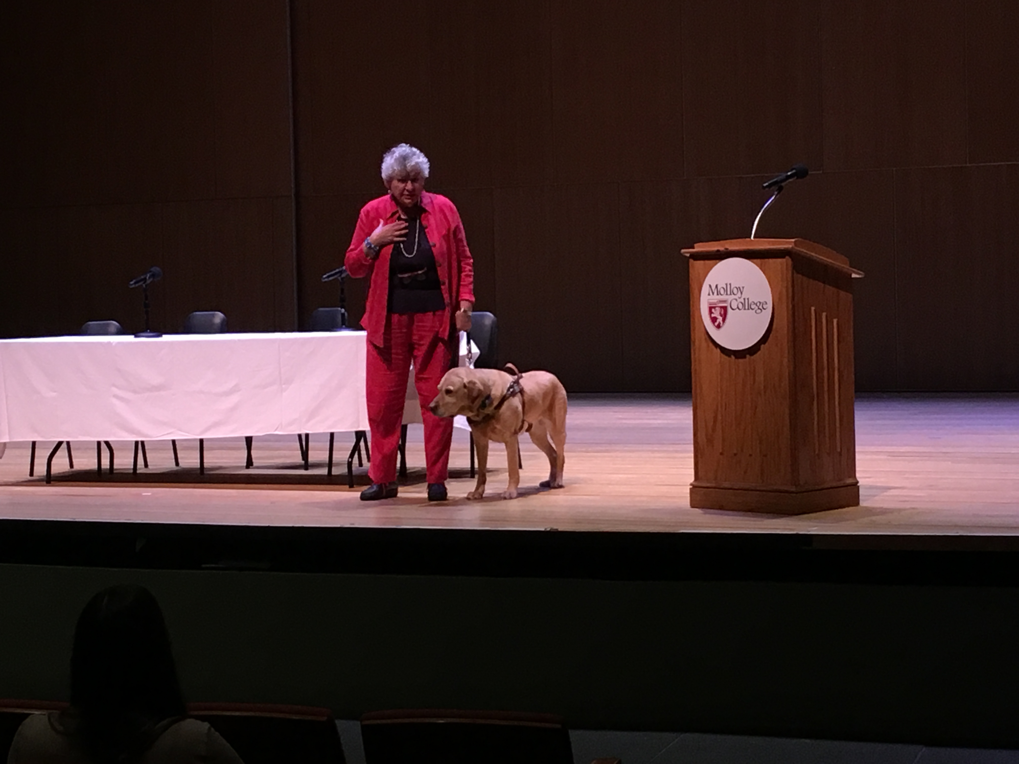
- Switch with friends, it is better to switch than call out when its snowing.

Guide Dog Foundation: Joan Lee
- There are different types of blindness, total, partial.
- Visually impaired since the age of 18
- Before getting a dog, the visually impaired person must be cane trained
- A bystander can not touch the dog, the dogs are working
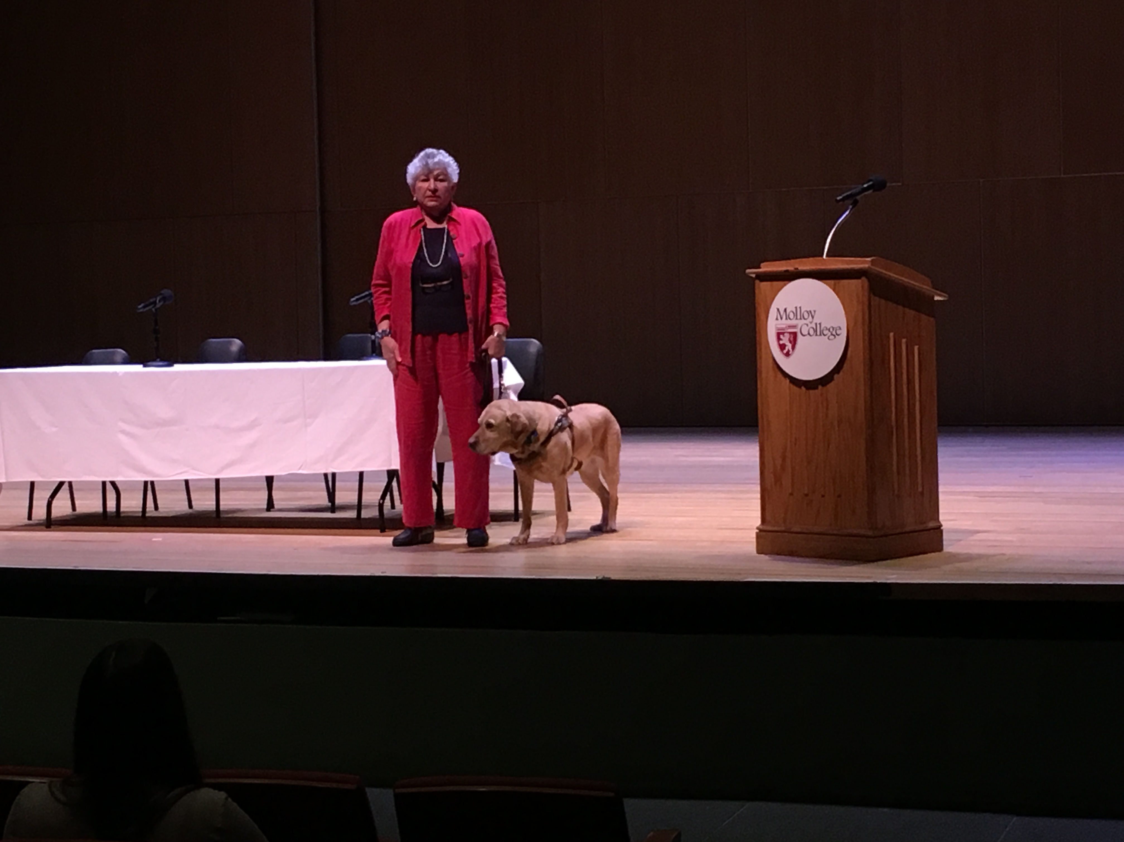
- Can the dog go to two the hospital with you?
  - No, only if she visits a patient
  - If she is the patient, the dog has to be walked etc.
- The insurance company does not pay for this.
- Cane training is done by a class
- Networking helps with the process of becoming cane trained
- To train a dog it costs 50,000

