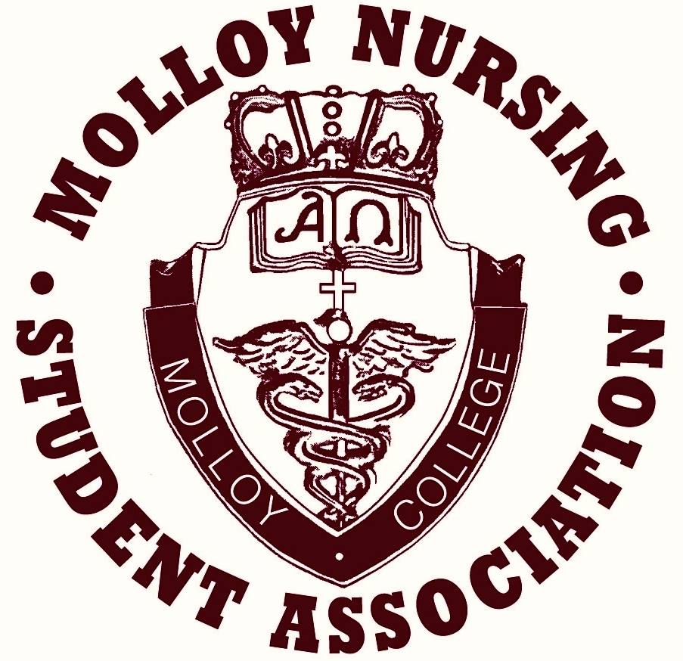

Place your order for you comfy, stylish MNSA Gear! We will be on the 2nd floor of Casey, outside the nursing lab during the following dates and times:
Tuesday, September 29th - 10am-5pm
Wednesday, September 30th - 10am-5pm
Thursday, October 1st - 10am-7pm

